H.T No
Regulations:
A17

Sreenidhi Institute of Science and Technology
(An Autonomous Institution)
Code No: 6EC13 Date: 05-Oct-2021(AN)

B.Tech III-Year II- Semester External Examination, Sept/Oct - 2021 (Supplementary)

MACHINE LEARNING (CSE, IT and ECM)
Time: 3 Hours Max.Marks:75

Note: a) No additional answer sheets will be provided.
b) All sub-parts of a question must be answered at one place only, otherwise it will not be valued.
c) Missing data can be assumed suitably.

ANSWER ANY 5 OUT OF 8 QUESTIONS. EACH QUESTION CARRIES 15 MARKS.

Bloom's Cognitive Levels of Learning (BCLL)

Remember | L1 | Apply | L3 | Evaluate | L5
Understand | L2 | Analyze | L4 | Create | L6

 |  |  | BCLL | CO(s) | Marks
1. | a) | Consider a neuron with 2 inputs, 1 output, and a threshold activation function. If the two weights are w1 = 1 and w2 = 1, and the bias is b = −1.5, then what is the output for input (0, 0)? What about for inputs (1, 0), (0, 1), and (1, 1)? Draw the discriminant function for this function, and write down its equation. Does it correspond to any particular logic gate? | L2 | CO1 | [8M]
 | b) | Explain Finding a Maximally Specific Hypothesis Algorithm with an example. | L2 | CO1 | [7M]
2. | a) | Suppose that the following are a set of points in two classes:  Class 1: 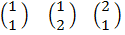  Class 2: 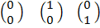  Plot the above Two Classes and find the optimal separating line. What are the support vectors, and what is the margin? | L2 | CO2 | [8M]
 | b) | Suppose that the local power company wants to predict electricity demand for the next 5 days. They have the data about daily demand for the last 5 years. Typically, the demand will be a number between 80 and 400.  - Describe how you could use an MLP to make the prediction. What parameters would you have to choose, and what do you think would be sensible values for them?  - If the weather forecast for the next day, being the estimated temperatures for daytime and night time, was available, how would you add that into your system? | L2 | CO2 | [7M]
3. | a) | Consider the following situation. When you arrive at a party, your five friends already have their drinks on the table. Jim has a job and buys the round half of the time. Jane buys the round a quarter of the time, and Sarah and Simon buy a round one eighth of the time. John hasn’t got his wallet out since you met him three years ago.  Compute the entropy of each of them buying the round and determine how many questions you need to ask (on average) to find out who bought the round.  Two more friends now arrive and everybody spontaneously decides that it is your turn to buy a round (for all eight of you). Your friends set you the challenge of deciding who is drinking Coke and who is drinking Mango Juice according to their gender, whether or not they are students, and whether they went to the party last night as well. Use ID3 to determine it and draw the Pruned Tree for the following table | L3 | CO3 | [8M]
  Drink | Gender | Student | Party Last Night
  Coke | T | T | T
  Coke | T | F | T
  Mango Juice | T | F | F
  Mango Juice | T | F | F
  Mango Juice | F | T | T
  Mango Juice | F | F | F
  Mango Juice | F | T | T
  Mango Juice | F | T | T
 | b) | Explain ID3 Algorithm with an Example. | L2 | CO3 | [7M]
4. | a) | Explain Linear Discriminant Analysis with an example. | L2 | CO4 | [8M]
 | b) | Illustrate the application of Genetic Algorithm in Map Coloring, Punctuated Equilibrium. | L3 | CO4 | [7M]
5. | a) | Suppose that there is a coin and there is person demonstrating that the coin is fair, but then makes it turn up heads many times in a row. You notice that he actually has two coins, and swaps between them with sleight-of-hand.  Watching, you start to see that he sticks to the fair coin with probability 0.4, and to the biased coin with probability 0.1, and that the biased coin seems to come up heads about 85% of the time. Construct a hidden Markov model for this problem, construct an observation sequence, and use the Viterbi algorithm to estimate the states. | L3 | CO5 | [8M]
 | b) | Compute the most likely path through the HMM shown in Figure below, using the Viterbi algorithm.  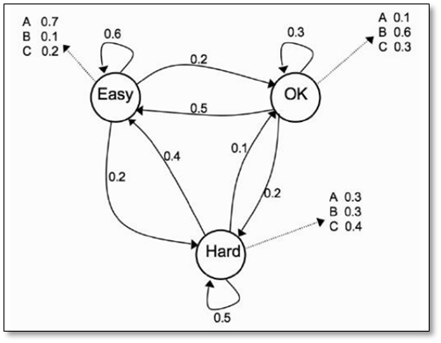 | L3 | CO5 | [7M]
6. | a) | Illustrate with an example Inductive Bias in Explanation Based Learning. | L3 | CO6 | [8M]
 | b) | Explain the use of Explanation Based Learning in Discovering New Features. | L2 | CO6 | [7M]
7. | a) | Explain the Perceptron Convergence Theorem. | L2 | CO1 | [5M]
 | b) | Explain Sequential and Batch Training in Multi-Layer Perceptron. | L2 | CO2 | [5M]
 | c) | Suppose that the probability of five events are P(first) = 0.5, and P(second) = P(third) = P(fourth) = P(fifth) = 0.125. Calculate the entropy. | L3 | CO3 | [5M]
8. | a) | Explain the Basic Genetic Algorithm with an example. | L2 | CO4 | [5M]
 | b) | Explain HMM forward algorithm. | L2 | CO5 | [5M]
 | c) | Describe Knowledge Level Learning. | L2 | CO6 | [5M]
-- 00 -- 00 –

